- Configure VPC peering in cross regions.
Objective
Connect two VPCs located in different AWS Regions.
Prerequisites
- Two VPCs in different regions
- CIDR ranges must not overlap
- Two EC2 instances (optional for testing)
Steps
- Create VPC-A (Mumbai).
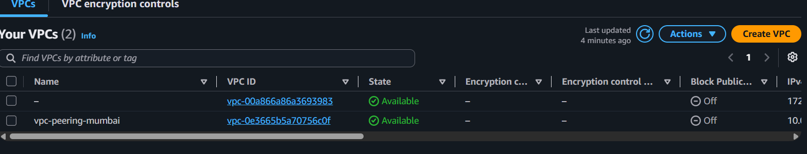
- Create VPC-B (Virginia).
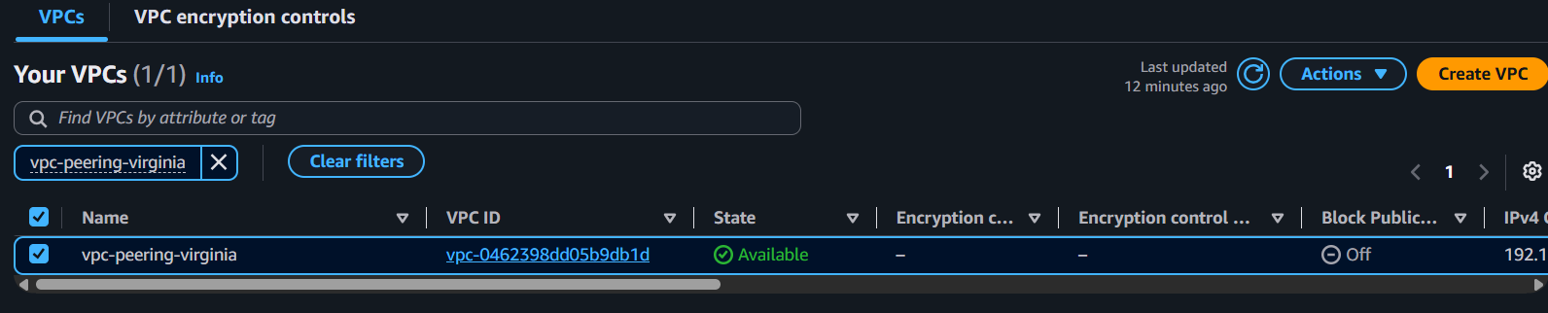
- Create a VPC Peering Connection.
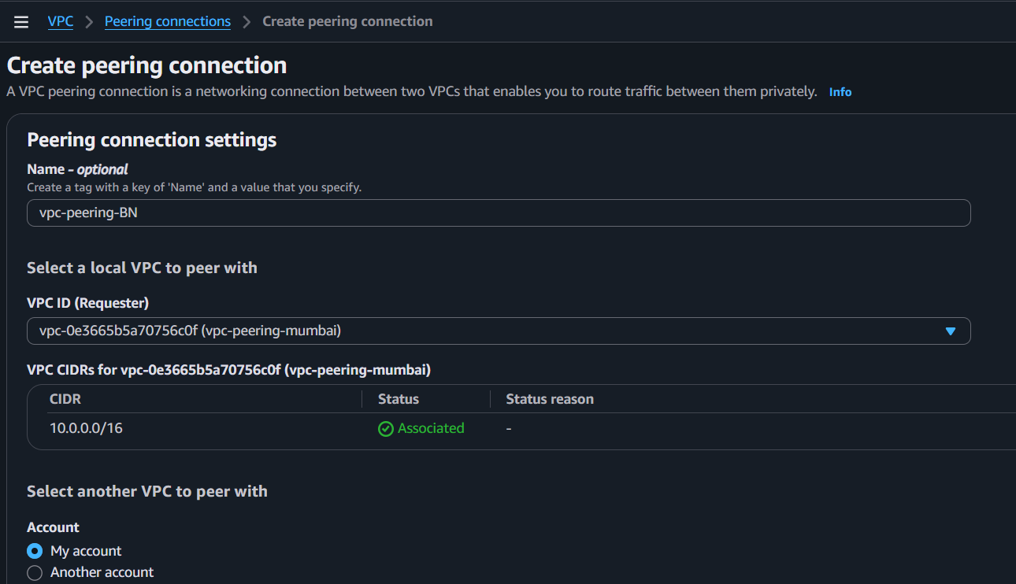

- Select:
  - Requester VPC → Region 1
  - Accepter VPC → Region 2
- Accept the peering request from Region 2.
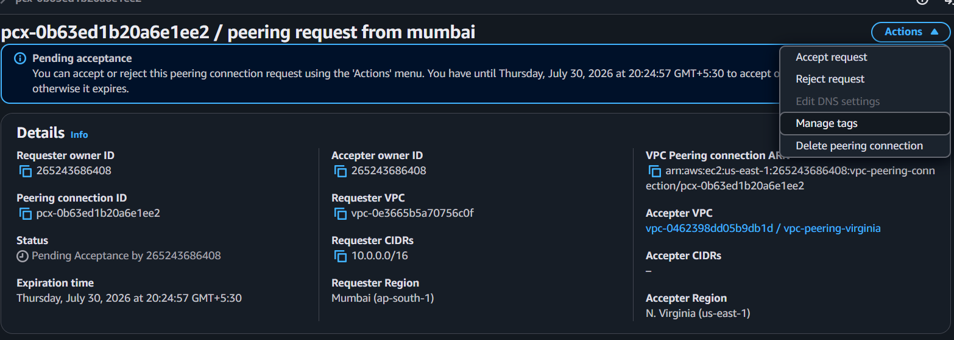
- Update route tables in both VPCs.
- Allow ICMP/SSH in Security Groups.
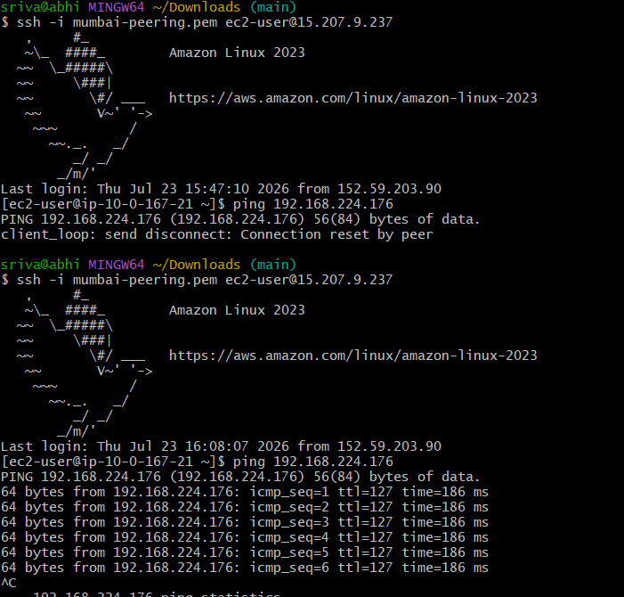
- Test connectivity using ping or ssh.

- Purchase one domain from GoDaddy.
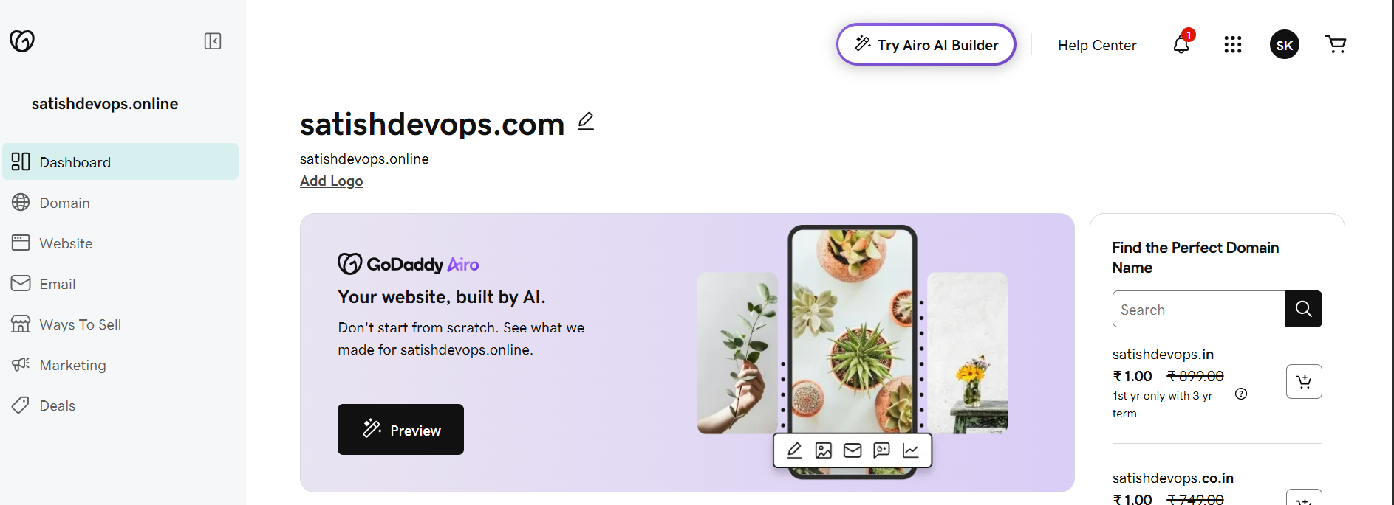

- Deploy static website in S3.
Step 1: Create an S3 Bucket
- AWS Console → S3 → Create bucket
- Bucket name: satishdevops.online
- Region: Choose your preferred region.
- Uncheck Block all public access.
- Click Create bucket.
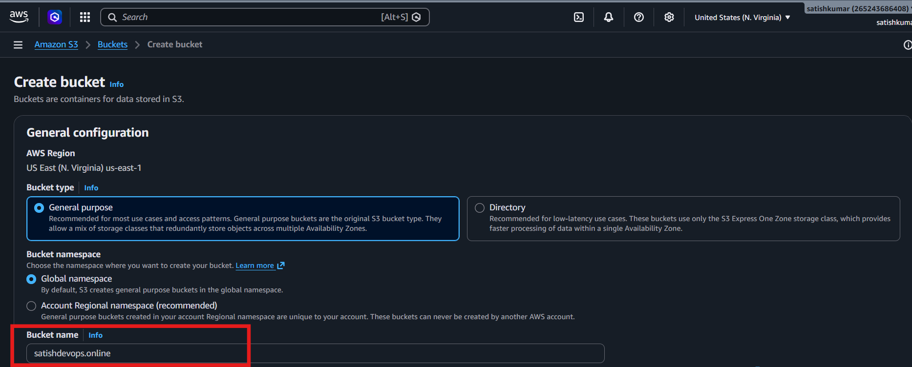

Step 2: Upload Website Files
- Open the bucket.
- Click Upload.
- Upload:
  - index.html
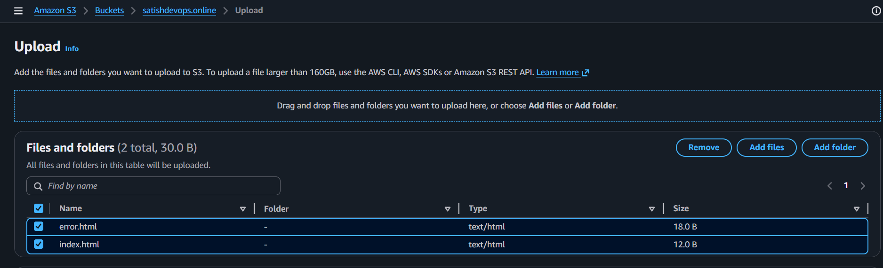
  - error.html

Step 3: Enable Static Website Hosting
- Go to Properties.
- Scroll to Static website hosting.
- Click Edit.
- Enable Static website hosting.
- Hosting type: Host a static website.
- Index document: index.html
- Error document: error.html
- Click Save changes.
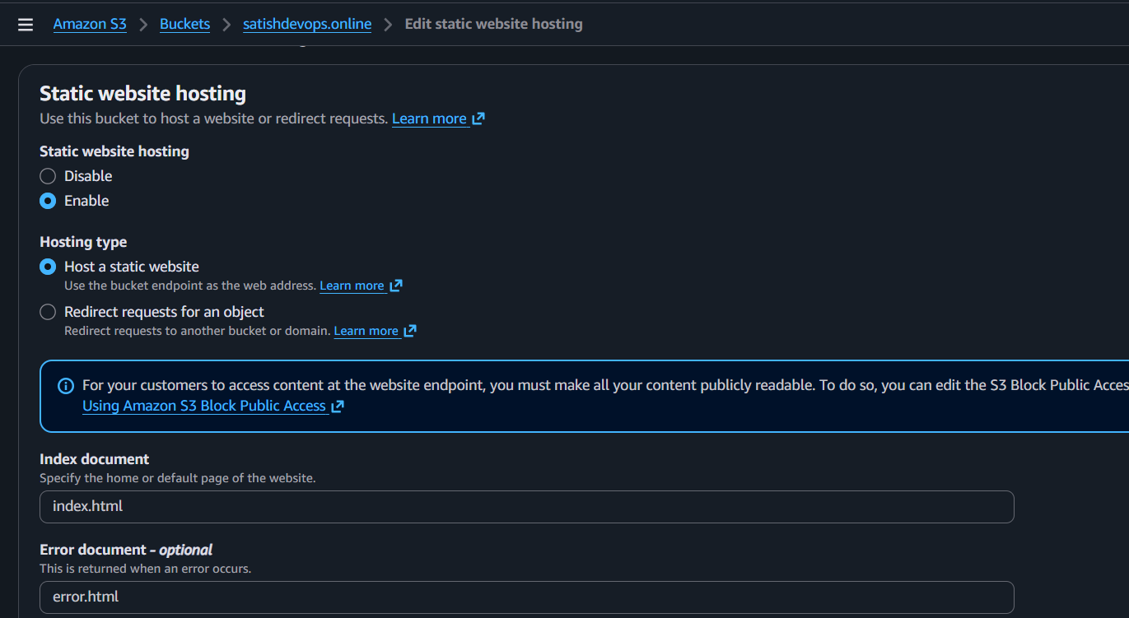

Step 4: Add Bucket Policy
Go to Permissions → Bucket Policy → Paste:
Click Save.
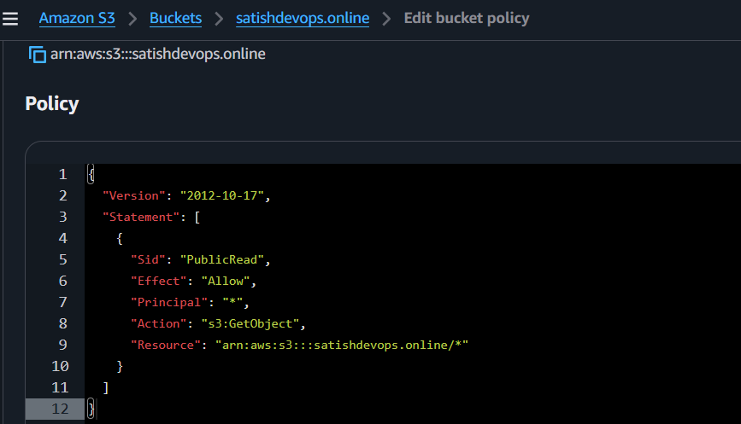

Step 5: Test the Website
- Go to Properties.
- Copy the Bucket Website Endpoint.
- Open it in your browser.
- Your website should load.
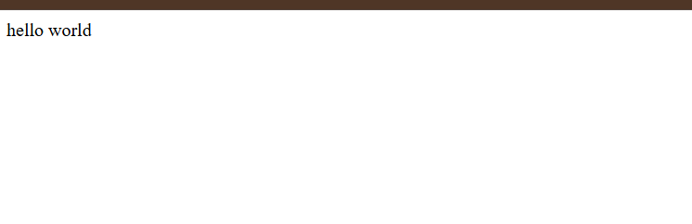

- Create a CDN and attach one SSL certificate.
Outcome
A CloudFront distribution is created and secured with an SSL/TLS certificate, allowing users to access the website over HTTPS.
Objective
To improve website performance using a CDN and secure traffic using HTTPS.
Prerequisites
- AWS Account
- Static website hosted in an S3 bucket (or another supported origin)
- Domain name (optional but recommended)
- Public hosted zone in Route 53 (if using a custom domain)

Step 1: Request an SSL Certificate
Important: CloudFront accepts ACM certificates only from the N. Virginia (us-east-1) region.
- Open AWS Certificate Manager (ACM).
- Switch to N. Virginia (us-east-1).
- Click Request Certificate.
- Select Request a public certificate.
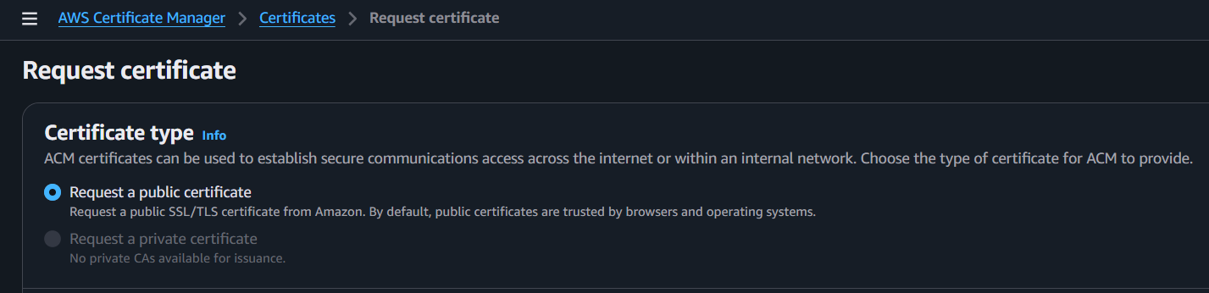
- Enter your domain name:
- Choose DNS Validation.
- Click Request.
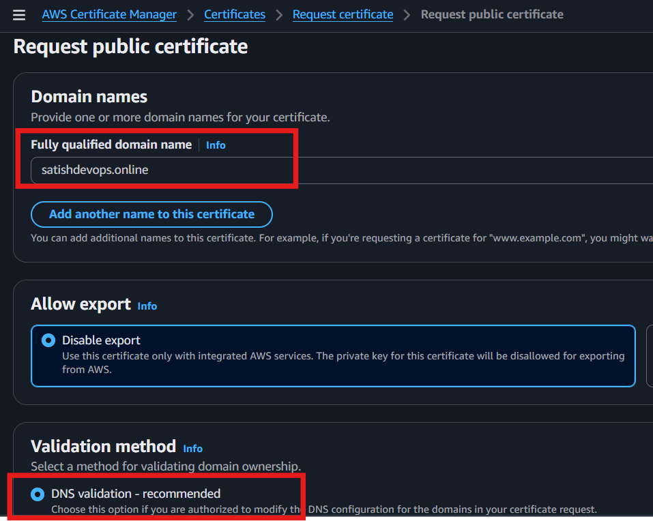
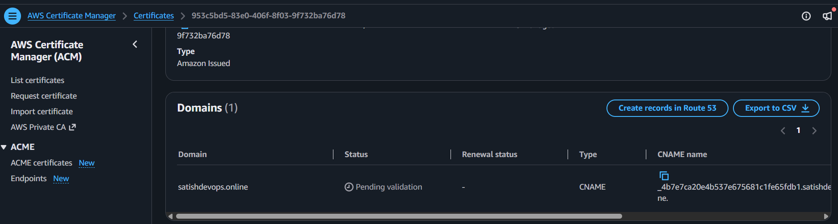

- GoDaddy Add the provided CNAME record to your DNS (your domain provider).
Step 2: Add the Record in GoDaddy
- Log in to GoDaddy.
- Go to Domains.
- Select satishdevops.online.
- Click DNS or Manage DNS.
- Click Add Record.
  - Domain Name: satishdevops.online
  - Status: Pending validation
  - A CNAME Name
  - A CNAME Value

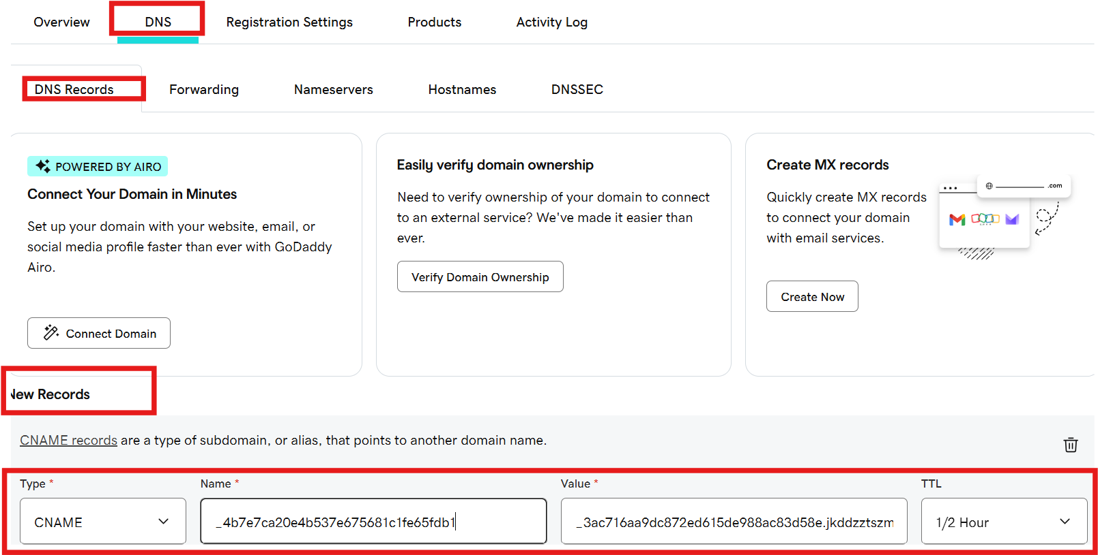
_4b7e7ca20e4b537e675681c1fe65fdb1.satishdevops.online.
- Wait until the certificate status changes to Issued.
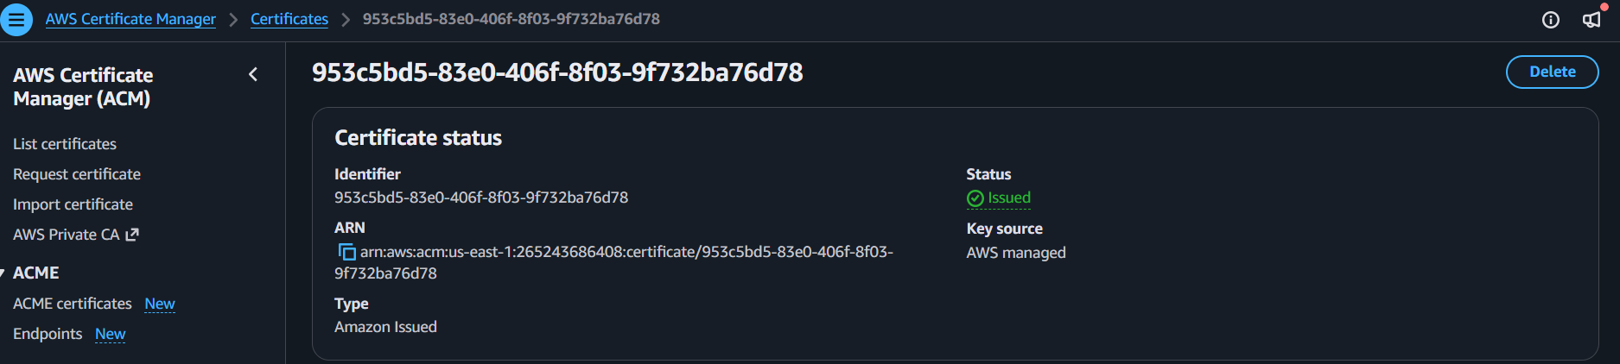

Step 2: Create a CloudFront Distribution
- Open CloudFront.
- Click Create Distribution.
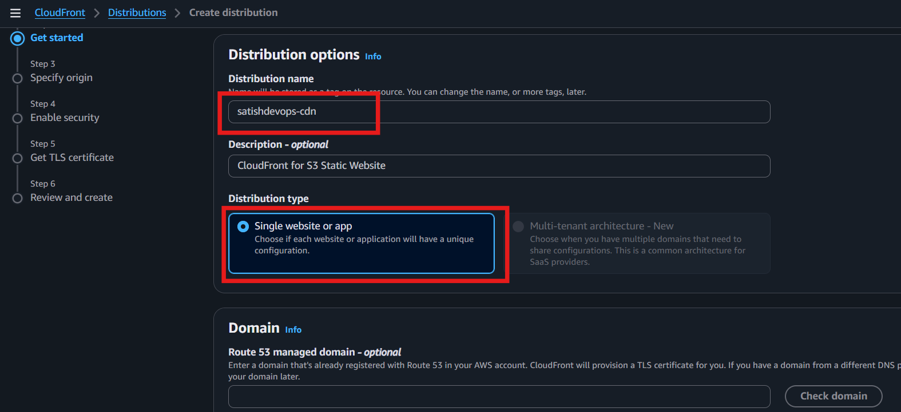

- Under Origin, select your S3 bucket (or other origin).
For a static website hosted in S3, configure the Origin section like this.
1. Origin type
Select:
✅ Amazon S3

2. S3 origin
Click Browse S3.
Select your bucket: satishdevops.online

3. Origin path
Leave it blank.

5. Origin settings
Select:
✅ Use recommended origin settings

6. Cache settings
Select:
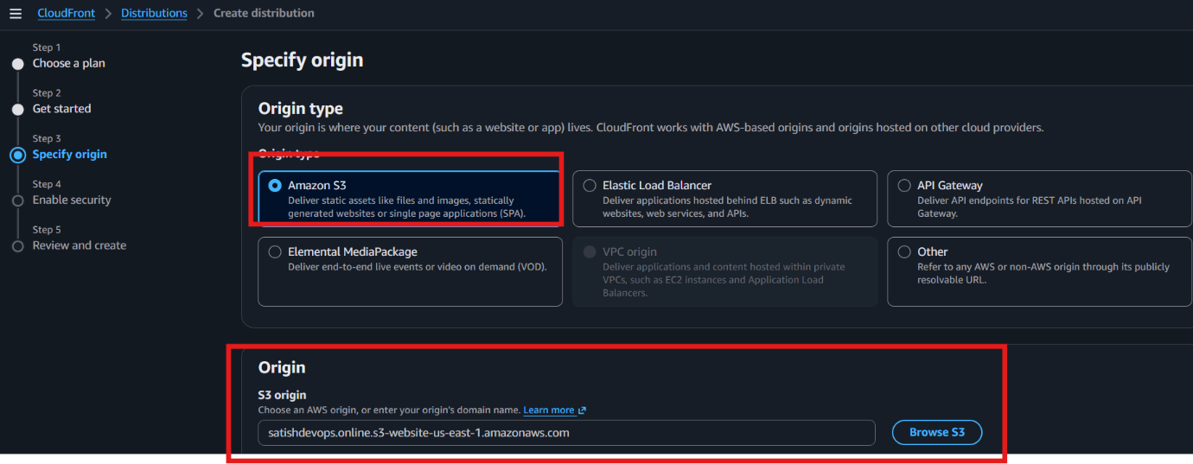
✅ Use recommended cache settings tailored to serving S3 content

Enable security
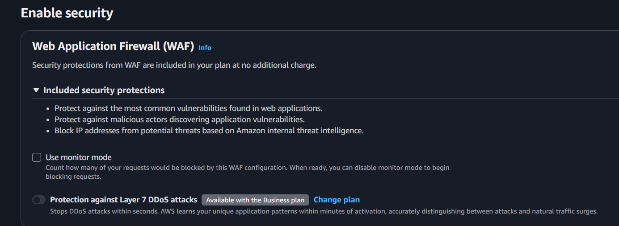
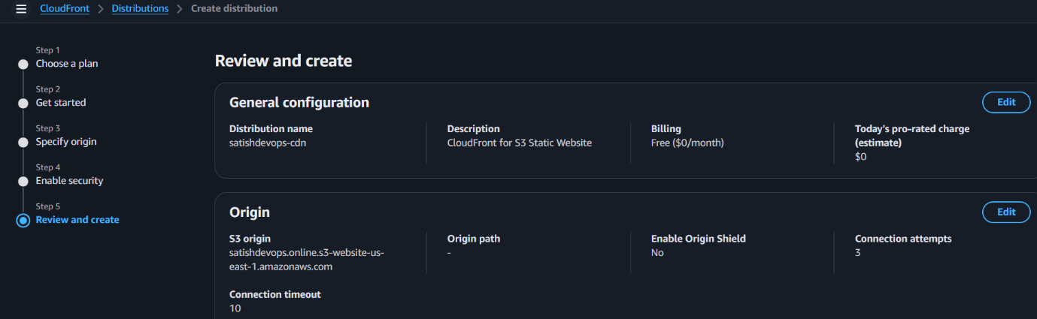
Review and create
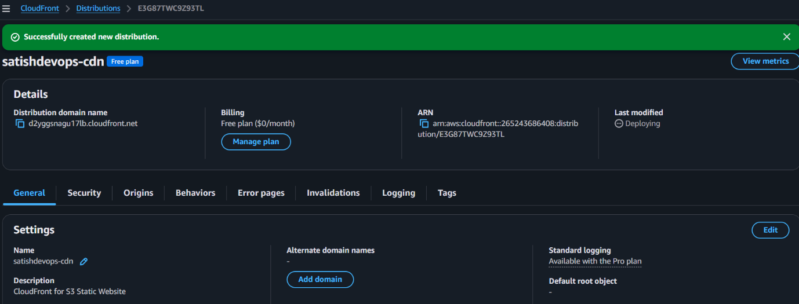
Click Create Distribution.

Step 3: Wait for Deployment
- Go to CloudFront → Distributions.
- Wait until the Status becomes:
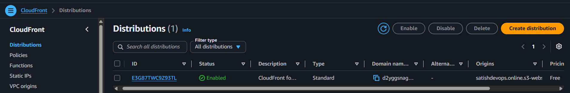
Step 4: Copy the Distribution Domain Name
Example:
d123abcdxyz.cloudfront.net
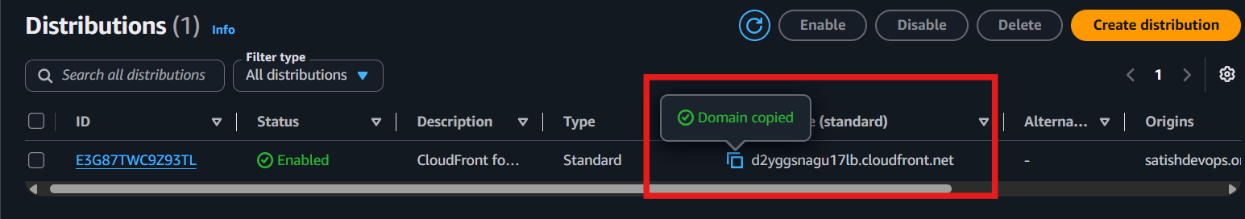

Step 3: Check Your ACM Certificate
Go to:
AWS Certificate Manager (ACM) (Region: N. Virginia / us-east-1)
Check the certificate status.
- ✅ Issued → Continue to Step 4.

- Create a Route 53 hosted zone and map the domain with the CDN.
Step 1: Create a Hosted Zone
- Open AWS Console.
- Search Route 53.
- Click Hosted zones.
- Click Create hosted zone.
Fill in:
- Domain name: satishdevops.online
- Type:
Public hosted zone
- Click Create hosted zone.
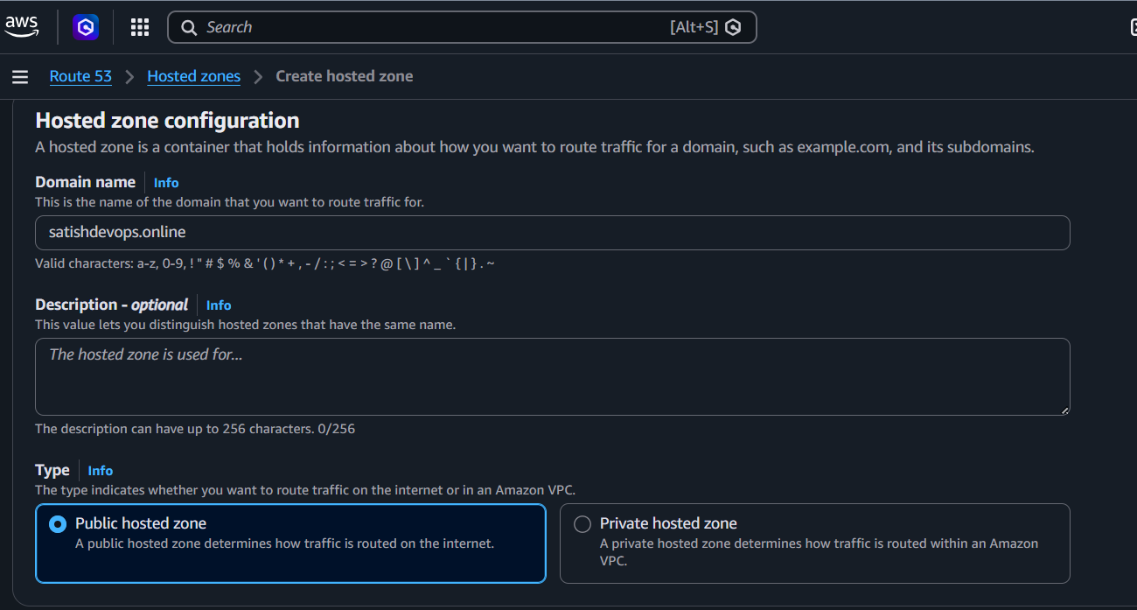

Step 2: Copy the Name Servers
After the hosted zone is created, you'll see NS and SOA records.
Open the NS record and copy the 4 Name Servers, for example:
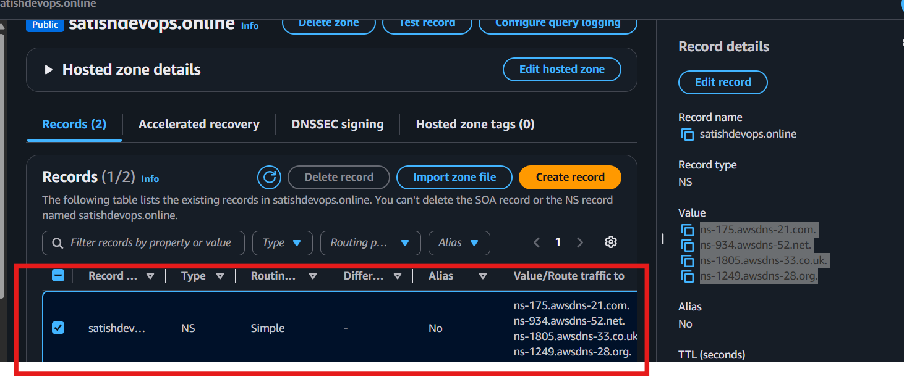

Step 3: Update GoDaddy Nameservers
- Log in to GoDaddy.
- Go to My Products.
- Click DNS or Manage DNS.
- Find Nameservers.
- Click Change.
- Choose:
I'll use my own nameservers
- Replace the GoDaddy nameservers with the 4 Route 53 NS records.
- Save.
DNS propagation may take from a few minutes up to 24–48 hours.
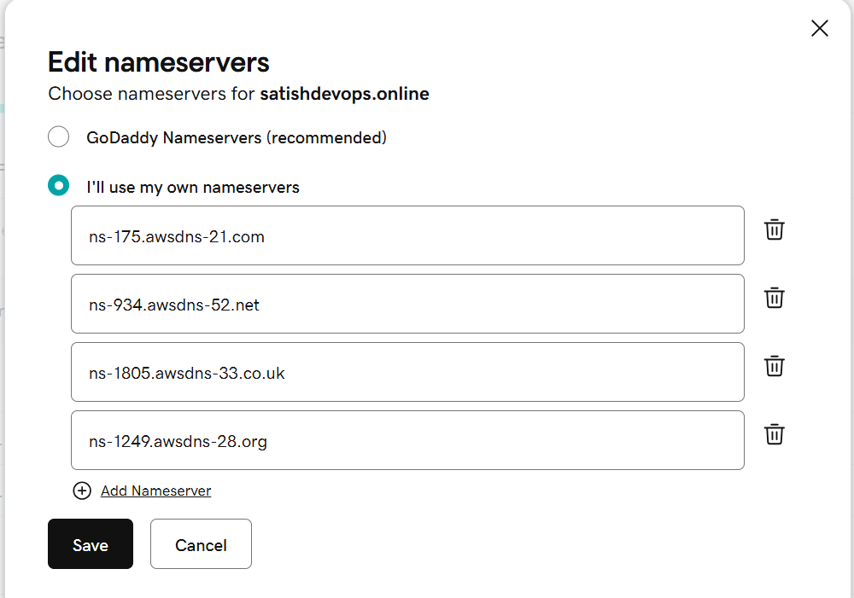

Step 4: Create an Alias Record in Route 53
After the nameservers have propagated:
- Open Route 53.
- Open your hosted zone.
- Click Create record.
Configure:
- Record name: Leave blank (for satishdevops.online)
- Record type: A
- Alias: Yes
- Route traffic to: Alias to CloudFront distribution
- Select your CloudFront distribution:
d2yggsnagu17lb.cloudfront.net
Click Create records.
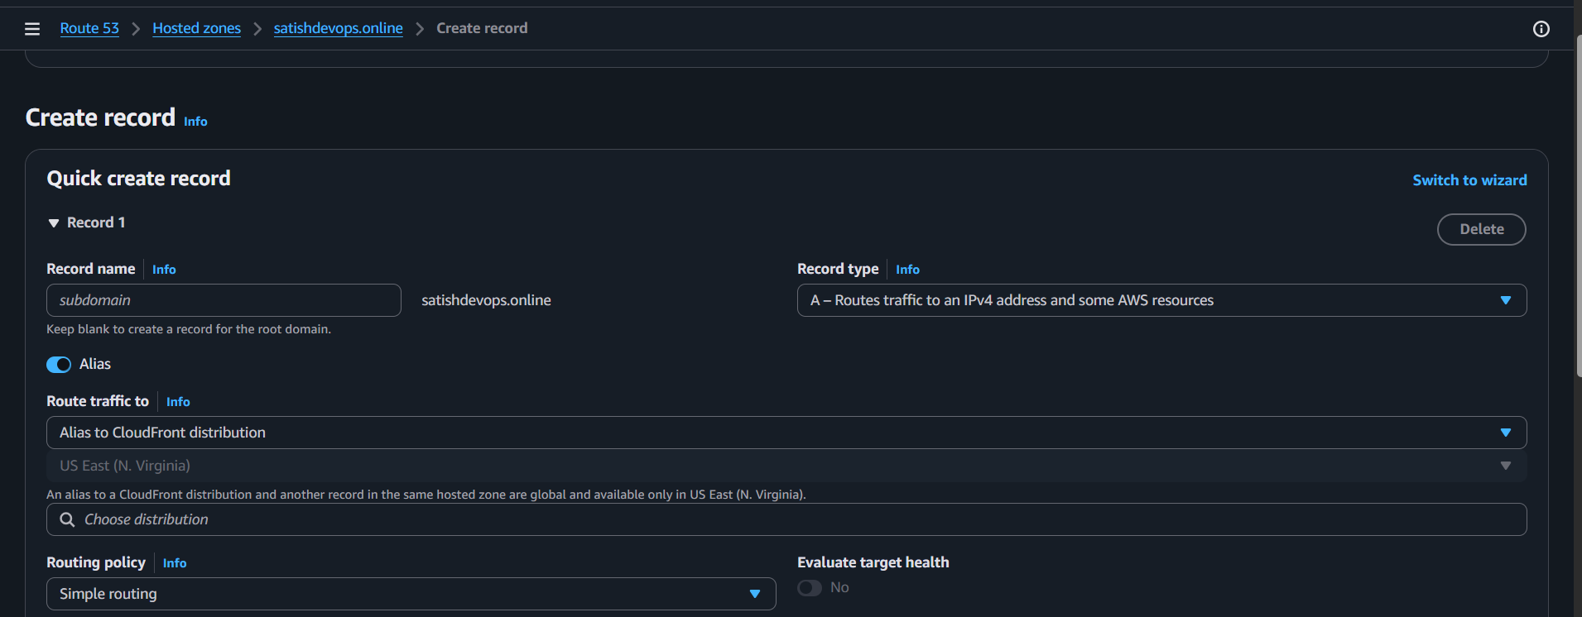

Step 5: Create a www Record
Click Create record again.
- Record name: www
- Type: A
- Alias: Yes
- Alias target: Same CloudFront distribution.
Click Create records.
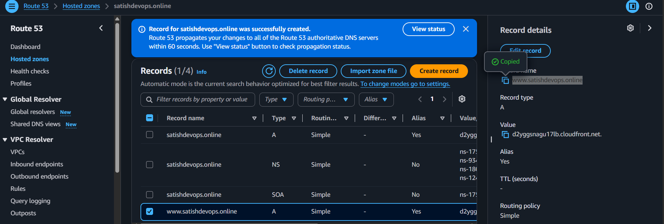

Step 6: Test
After DNS propagation, open:
- https://satishdevops.online
- https://www.satishdevops.online
Both should load your CloudFront-served S3 website over HTTPS.


- Update the index.html in the S3 bucket and ensure the updated file is accessible using the domain name.
Objective
Update the website content stored in the S3 bucket and verify that the updated content is accessible through the custom domain.

Step 1: Edit index.html
Open the index.html file on your computer and change the content.
Save the file.
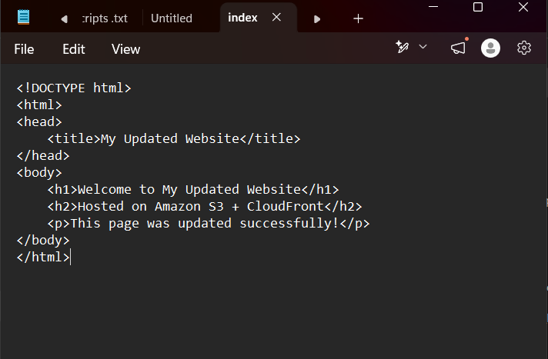

Step 2: Upload the updated file
- Open AWS Console
- Go to S3
- Open your website bucket.
- Select index.html
- Click Upload
- Choose the updated index.html
- Click Upload
The old file will be replaced.
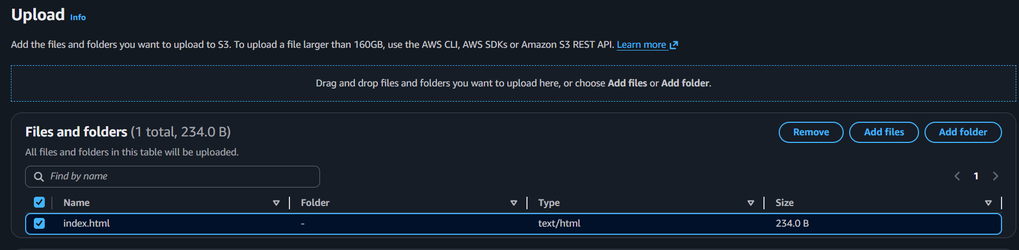

Step 3: If using CloudFront, invalidate the cache
Without invalidation, CloudFront may continue serving the old page.
- Open CloudFront
- Select your distribution.
- Go to Invalidations
- Click Create Invalidation
- Enter:
/*
- Click Create Invalidation
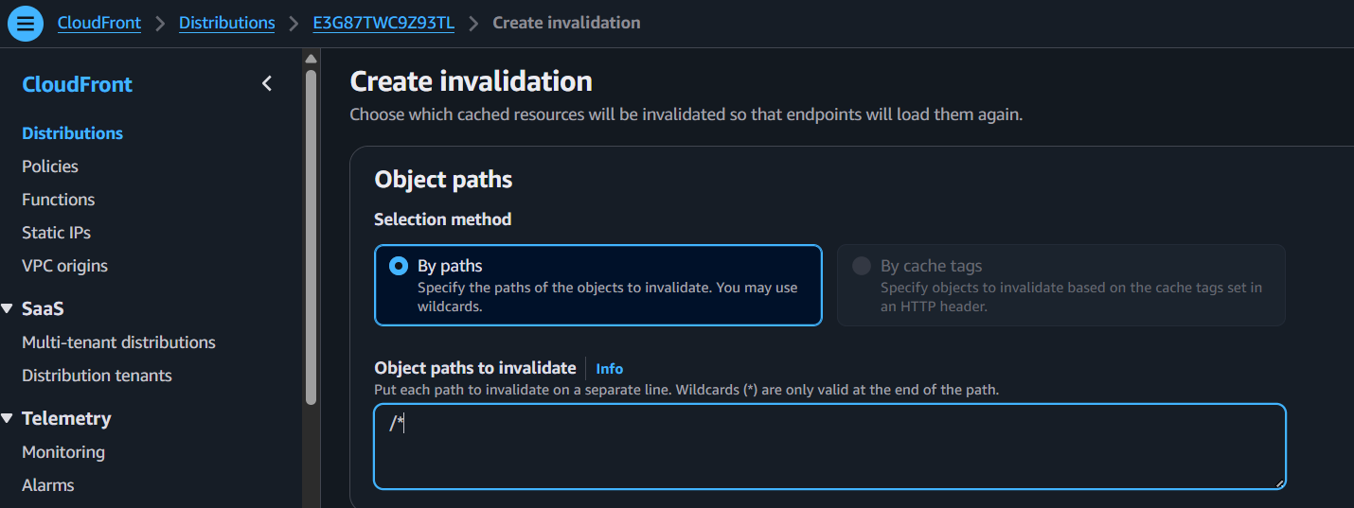
Wait until the status changes to Completed (usually 2–10 minutes).

Step 4: Verify using your domain

